**Meet Vanco Mobile, the new app for your church.**  
[Apple_App_Store_Button](https://apps.apple.com/us/app/vanco-mobile-faith-engagement/id1504961674)  [Google_Play_Store_Button](https://play.google.com/store/apps/details?id=com.vancopayments.vancomobile&hl=en_US&gl=US)

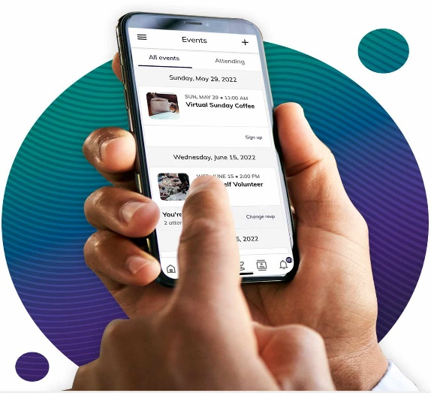

**VANCO Mobile ….** Online giving through your phone

Making Donations Using VANCO Mobile …

***Where can I download the VANCO Mobile app?***

Currently, VANCO Mobile is available through Apple’s App Store and Google’s Play Store.

***Is the VANCO Mobile app free to use?***

Yes! The app is free to download from Apple’s App Store and Google’s Play Store.

***How do I find my church to give in the VANCO Mobile app?***

When you download the app for the first time, you will be prompted to enter the name of the church to which you want to give. You can type the name of the church and select it when it appears. We are listed under “First Lutheran Church of Hinckley.”

***What payment methods can I use to donate?***

VANCO Mobile donations can be made with some major credit cards and debit cards.

An offset processing fee, can be added to your charge to cover the cost of using credit card. Thank you!

Any questions …. You can call me on Wednesdays or Thursdays at church, from 9:00 to 3:00.

Thank you,

Kathy Thompson

Financial Secretary

+++++++++++++++++++++++++++++++++++++++

**Engaging in your church community with Vanco Mobile is as easy as 1-2-3.**

1. Download the Vanco Mobile app from the [Apple App Store](https://apps.apple.com/us/app/vanco-mobile-faith-engagement/id1504961674) or [Google Play Store.](https://play.google.com/store/apps/details?id=com.vancopayments.vancomobile&hl=en_US&gl=US)
2. Find your church and log in by setting up your user account in minutes.

Use the “Near me” tile and **Press** it

When the First Lutheran Church

301 Lawler

Hinckley MN 55037

tile shows, **Press**on that and you are ready to set up your User Account and start to donate!

**Church has changed. See how Vanco Mobile helps.**