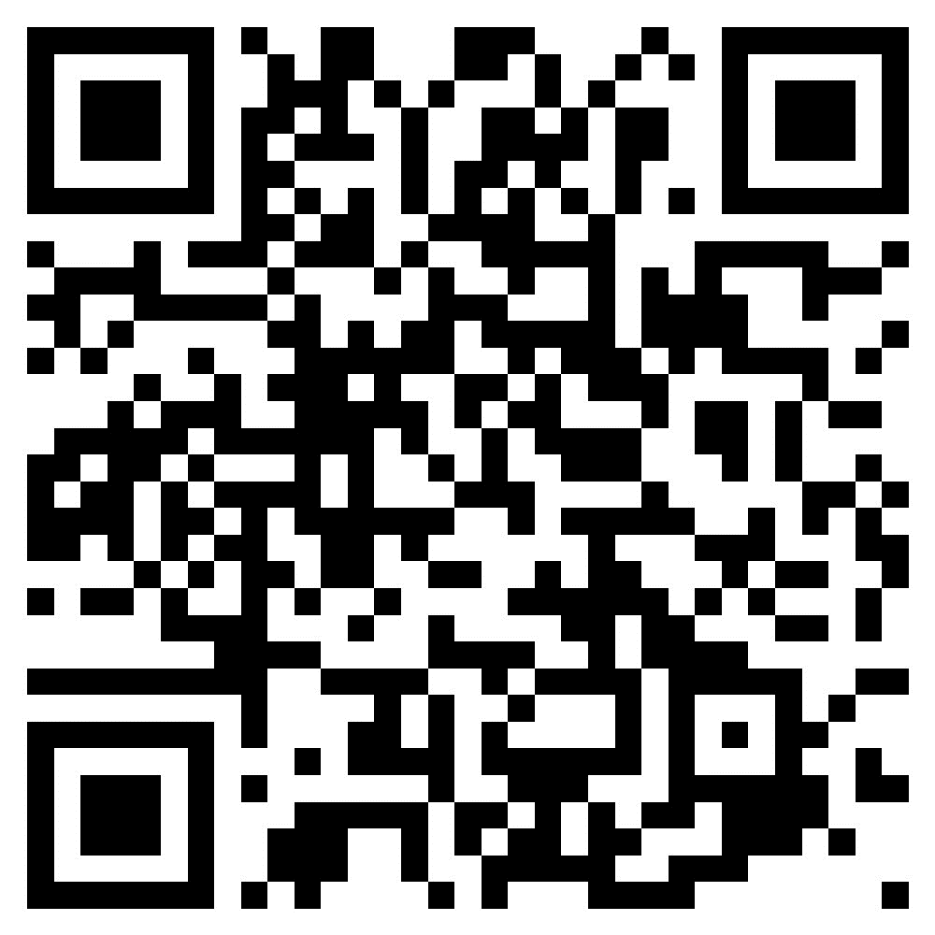
First Lutheran Church, Hinckley MN QR Code
For Online Giving
A QR Code is what links you to our church’s Mobile Giving, so you can donate through your phone. Just scan this code on your phone’s camera, and it will show you a link (if not, you will have to download a QR Code Scanner application)– click on the link provided and it will bring you to our Mobile Giving application, where you can easily donate.
Any questions, contact Kathy T (Financial Secretary). Thank you!

