First EDITION
February 2023

“We are called by God to grow in faith together, sharing Christ’s love with each other and our community.”
Yet the LORD longs to be gracious to you; therefore he will rise up to show you compassion. For the LORD is a God of justice. Blessed are all who wait for him!" Isaiah 30:18
Lent is coming up again. Thank you Jesus, as we've finally gotten back to some normalcy in life and are gathering in church for worship. What a blessing that has been to be with one another here, in coffee shops, restaurants, at family gatherings and seeing friends again in person! Zoom meetings and calls are still taking place but now for convenience rather than due to a pandemic. I'm prayerful that we've turned a corner as this was a very difficult several years.
As we begin Lent this 2023 I think about a new series Christie and I have been watching called "The Chosen" and in one episode Jesus enters a room with Jairus, Peter, James and John to see Jairus' daughter lying dead in a bed with her mother crying at her side. It's impossible to imagine the discussion between Jairus and his wife as he tries consoling her. In Mark 5:41 we read "He took her by the hand and said to her, "Talitha, koum," which means, "Little girl, I tell you to get up!" and she got up at once and started walking around (she was 12 years old). When I think about lent, this story seems to enter my mind and how I've heard it many times and even places I've heard the story told come back to me. What a beautiful thought that Jesus brought her back to life but also to think of our own resurrection and where we'll be one day.
Like in the story of Jairus' daughter who was given hope as he found Jesus, Lent gives us hope in the midst of life's despair because of whom we are, children of God. Let's give ourselves a break. Give each other grace and peace and continue to trust in God.

Rick Dunkley-Council President

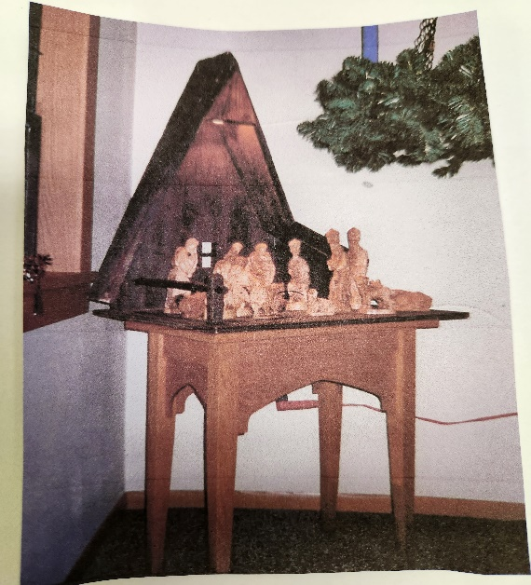

Many gifts…….
Our Nativity Scene is made from Monkey pod and needs to be annually rubbed down with olive oil. A past member bought is when she was in the Holy Land. Her name was Ethel Jackson.

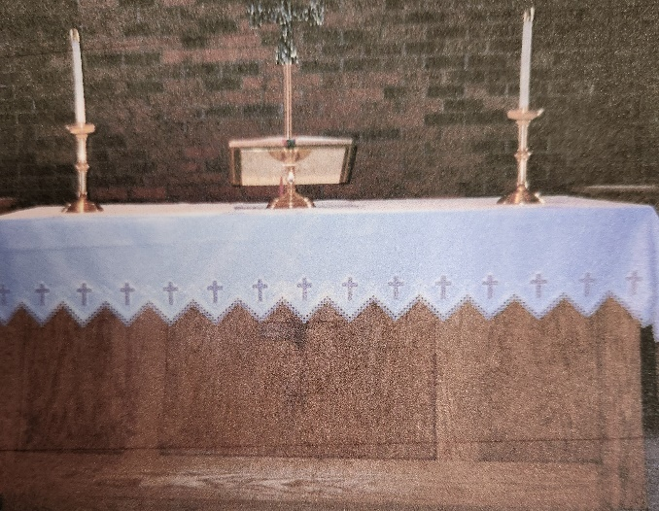

Our altar parament was donated by Mrs. Pat Almos’s mother, who did all the tatting.
The oil candles were donated by Lily Beth Frentz (daughter of Leonard and Eileen Wahlberg) in memory of her husband.

Many, many thanks…….

Prayer Concerns and Sympathy ~ Virgil Seegebarth, Colleen Volden, Jerry Shober, Bradley Fairbanks, Leigha Ness, Kathy Thompson, Lana Jensen, Wally Guptill, Yvonne Guptill, Drew (Mindy’s brother), and Marsha Skoog (friend of Patty Sweeny).

Care facility member ~Dorothy Svendsen.
For firefighters, EMT’s, those who serve to protect Policemen and women and military.
For world peace.
For our companion synods.
For our missionaries: Jacqueline and Patrick Bencke
The Noisy Offering for February goes for
Pastor’s Discretionary Fund.
Baptized at our font on January 15, 2023, was Lane Williams Davis, his parents are Dalton and Amanda Davis. His sponsors are Nels Olander and Jenni Olander.
Congregational sponsor is Juanita Zamora.
We welcome Lane into the family of God at First Lutheran.

Women’s Bible Study’s ongoing mission project
We ask members to join us and bring Shampoo during the month of February for the homeless.
Please put them in the basket marked “Homeless Packets” in the cabinet in the Narthex.
Thank you.

We need people to sign-up to serve coffee on the second Sunday of the month. Sign-up chart is on table in Narthex or contact Elaine Garaghty-763-229-1035.
Thank you to everyone that has helped shovel the sidewalks, we appreciated it!

All Boards will meet
Monday, February 27th at 6:30 pm. New Members will start that evening.

Ellie Nelson’s Family is having a 90th Birthday Party, Open House on Saturday, February 11th from Noon-4pm at the Hinckley Community Center.
All are invited to celebrate this special occasion.

Please Join us for the
Community Meal
5-6:30 pm the 1st Tuesday of Month-

February 7th
March 7th
April 4th
May 2nd
Out to Lunch Bunch
Thursday, February 16th
TBD
Lenten Soup and Worship

Would you be interested in an 11:30 am Lenten soup lunch and Noon Worship during Lent? We would like to hear from you. Call the office. Thank You.

Office Hours-Tues., Wed., Thurs. 9 am-3 pm

Mindy Johnson, Director of Youth and Family: 320-469-3774
Donna Martin, Church Secretary: Tuesday-Thursday 9-3
Kathy Thompson, Financial Secretary: Wednesday & Thursday
Rick Bicking, Treasurer: 320-237-0256

2/1 Diane Ausmus
Robert Kinblom
Gavin Hecht
2/3 Shawn Denton
Earl Koste
Linda Trott
2/4 Shalai Coulter
2/6 Elaine Jensen
2/8 Diane Erickson
Judy Peterson
2/11 Eleanor Nelson
2/15 Elsie Dieter
2/16 Brooklyn Storlie
2/17 Hollie Lindner
Shana Stiel
2/18 Charles Mans
2/20 Richard Anderson
Candi Nelson
2/21 Rebecca Wiczek
2/22 Allyce Mulder
Madalynn VanGorden
2/23 John Shober Jr.
Cade Thurner
2/24 Olivia Erickson
Easton Mettling
2/26 Katlyn Dunkley
Lori Klar
2/27 Paige Denton

Octogenarians
Please let us know if there are any corrections or additions.
Thank You!

February
Birthday’s

ACOLYTE, LECTORS, USHERS, KITCHEN AND ALTAR SCHEDULE FOR DECEMBER

Remember if you cannot serve, to please find your own substitute. Thank You

Wednesday, February 1-Bailey Skutevik

Sunday, February 5-Nolan Stiel, Kieran Tvedt

Wednesday, February 8-Sophie Warman

Sunday, February 12-Owen Johnson, Connor Olander

Wednesday, February 15-Thomas Wachsmuth

Sunday, February 19-Jaeden Fischer, Riley Scott

Ash Wednesday, February 22-Ava Blowers

Sunday, February 26-Blake Blowers, Preston Mettling

(Ashley Thompson - usually reads First Reading)

Sunday, February 5-Paul Olson

Sunday, February 12-Elaine Garaghty

Sunday, February 19-Christie Dunkley

Sunday, February 26-Donna Wachsmuth

February Ushers

Richard Anderson

Jerry Trott

Kitchen Cleaning

Joyce Seegebarth
Altar Committee
Linda Trott

Women’s Bible Study’s ongoing mission project.

We ask members to join us and bring a granola bars during the month of May for homeless packets. Please put them in the basket marked “Homeless Packets” in the cabinet in Narthex.
Thank You.

Thank you to Amy Johnson for taking care of plastic bag recycling.
We collected enough for a bench, and we will keep collecting hopefully for another bench.
Thank you for donating!

FEBRUARY 2023
**Subject to Change**
Worship Service is available Live on Facebbok, You Tube, and Website.

SUN |  | MON | TUES | WED | THURS | FRI | SAT
 |  |  |  | 1  6:30 pm Worship | 2  Mindy -Youth Extravaganza Feb. 1-7  8 am Men’s Text Study | 3 | 4  8 pm AA mtg.
5  8:30 am Coffee Fellowship  9:30 am Worship |  | 6  Mindy-Youth Extravaganza Feb. 1-7 | 7  9:30 am Women’s Bible Study  5-6:30 pm  Community Meal | 8  11 am Staff mtg.  6:30 pm Worship | 9  8 am Men’s Text Study  9 am Quilting | 10 | 11  Noon-4pm  Ellie Nelson 90th Birthday Party at Hinckley Community .Center  8 pm AA mtg.
12  8;30 am Coffee Fellowship  9:30 am Worship  11 am-12:30 pm  Valentine’s Dinner |  | 13  9 am Library  4 pm Women’s Roman’s Bible Study | 14  9:30 am Women’s Bible Study | 15  6:30 pm Worship | 16  8 am Men’s Text Study  Out to Lunch Bunch TBD | 17 | 18  4-8 pm  Wild Mountain Skiing/Tubing-  Taylors Falls  8 pm AA mtg.
19  8:30 am Coffee Fellowship with  BP checks  9:30 am First Word Worship  Church Council |  | 20 | 21  9:30 Women’s Bible Study | 22  ASH WEDNESDAY  6:30 Worship | 23  8 am Men’s Text Study | 24 | 25  9-3 Lay Leader  Gathering-Brainerd  8 pm AA mtg.
26  8:30 am Coffee Fellowship  9:30 am Worship |  | 27  6:30 pm All Boards-New Members start | 28  9:30 am Women’s Bible Study | Wednesday Night Youth Schedule  4:30 pm FiA Choir  5-7 pm Confirmation  5-6:30 pm FiA  7-8 pm Youth Group

Treasurer’s Report
Financial Report for January 2023

 | Budget | YTD actual | Last Year
YTD Income | $233,420 | $161,654 | $201,654
YTD Expenses | $205,595 | $202,713 | $187,946

The Parish Nurse will be doing blood pressures for anyone who would like one, Sunday, February 19th during Coffee Fellowship.

OPPORTUNITIES to Volunteer and Have Fun at the same time. Do you like to get together and have coffee and have snacks? If you do come and join our DREAM TEAM. Last year we got together and made the decorations for VBS and the Fall Gathering. There's much more going on this year. We need you. You can come to one event or all of them. If you can’t make it to the event don't worry you won’t get fired. We'll just do a toast for you with our coffee cups.

This is what is going on:

MARCH: We will get together and work on props for Palm Sunday. We're going to fluff
up those palm trees. We may have a project for Good Friday. That's still in the planning
stage. If there is enough interest in a Mother/ Daughter Banquet, we would start planning it.

APRIL: Work on decorations for VBS and Mother/Daughter Banquet. Plan Garden tour.

MAY: Mother/ Daughter Banquet, VBS decorations, Finalize Garden tour.

JUNE: Set up and take down of VBS decorations, Garden Tour.

Doesn't that sound like fun? We'll be meeting on Thursdays and not a minute before 10 in the morning. No repercussions if you're late.

Contact Robin Hendrix if you are interested, even if you are mildly interested,
call me. 320-279-0961

WONDERING if there is interest in having a Mother/Daughter Banquet in May or June. The last one we had was 20 years ago. I think it’s about time for another one.
Let Mindy or Robin know your thoughts on this idea.

Giving statements are available to be picked up on the table in Narthex, upon request sent to you by mail or if you request by email Kathy will email them to you.
firstlcfinancialsecretary@scicable.com

“Jesus said; Let the children come to me”

Faith in Action and Youth Group: Reminder that Faith in Action will be every Wednesday night from 5:00-6:30and youth group will be from 7:00 – 8:00 and will follow the same schedule as FiA.

Souper Bowl of Caring: February 12th: Youth service project for February will be to participate in the “Souper Bowl of Caring”. We have done this project for 15years. This year youth are asking for donations of non parishable food to put in the blessing box and money will be collected in noisy offering during worship and will go towards purchasing food for blessing box. This will be a great way to lift up this ministry in our church.
Senior High Youth Gathering:
Flyers will be available on youth Bulletin Board – must register

Cardia Deo
March 18th
Cardio Deo is a retreat for high school youth in grades 9-12 and their adult leaders. As Christians, we are Called, Gathered, Equipped and Sent to be the Hearts of God (Cardia Deo) in world. Bible studies led by the LYO Board, servant learning, worship, camp life, and an adult track led by the retreat Chaplain all make this event a deeply meaningful, fun, and faith-nurturing event.

RURAL Music Ministries
Tickets available for Unspoken, March 12th in Grand Rapids.
Tickets are $ 20-sign-up on youth bulletin board.

Saturday, February 18
Wild Mountain/Taylors Falls
Family Fun -Skiing & Tubing

Skiing $ 49
Tubing $ 20

Youth Mission Trip
Valentine’s Dinner Fundraiser
Sunday, February 12th
11 am-12:30 pm
(Time change due to Super Bowl)

Free Will Offering
Menu:
Italian Spaghetti
Chicken Alfredo
Caesar Salad
Garlic Bread
Dessert

Roses and fudge will be available.
Happy Valentine’s

First Lutheran Church Non-Profit Organization
301 Lawler Avenue South U. S. Postage
P.O. Box 459 PAID
Hinckley, MN 55037 Hinckley, MN 55037
Permit No. 37
RETURN SERVICE REQUESTED

