

The Bencke Family in Japan

January 2024: 102番

Typically, the New Year in Japan is a four or five day celebration. People return to their hometowns and spend leisurely days eating, visiting relatives and friends, visiting shrines, and did I mention eating? Food is a huge part of New Year’s traditions here.

Tragically, this year on January 1st, the northern area of Japan was hit with a magnitude 7.6 earthquake and was followed by a 4.2 meter tsunami that devastated large areas of Ishikawa prefecture. Ishikawa is located on the western coast of Japan, along the Japan Sea and across from North Korea. This picture, while it may look like it was taken in Gaza, is what is left of that area of Ishikawa. The tsunami, earthquake, subsequent fires, and snow and rain that followed meant that very little was left. Even now, four weeks later, 13,000 people are still without running water, and are living in school gymnasiums or other spaces that were designated as emergency shelters.

The Japan Lutheran church has no established congregations in that area, so we are joining forces with a Christian support agency that was established after our Kumamoto earthquakes in 2016 to provide material and finanical assitance.

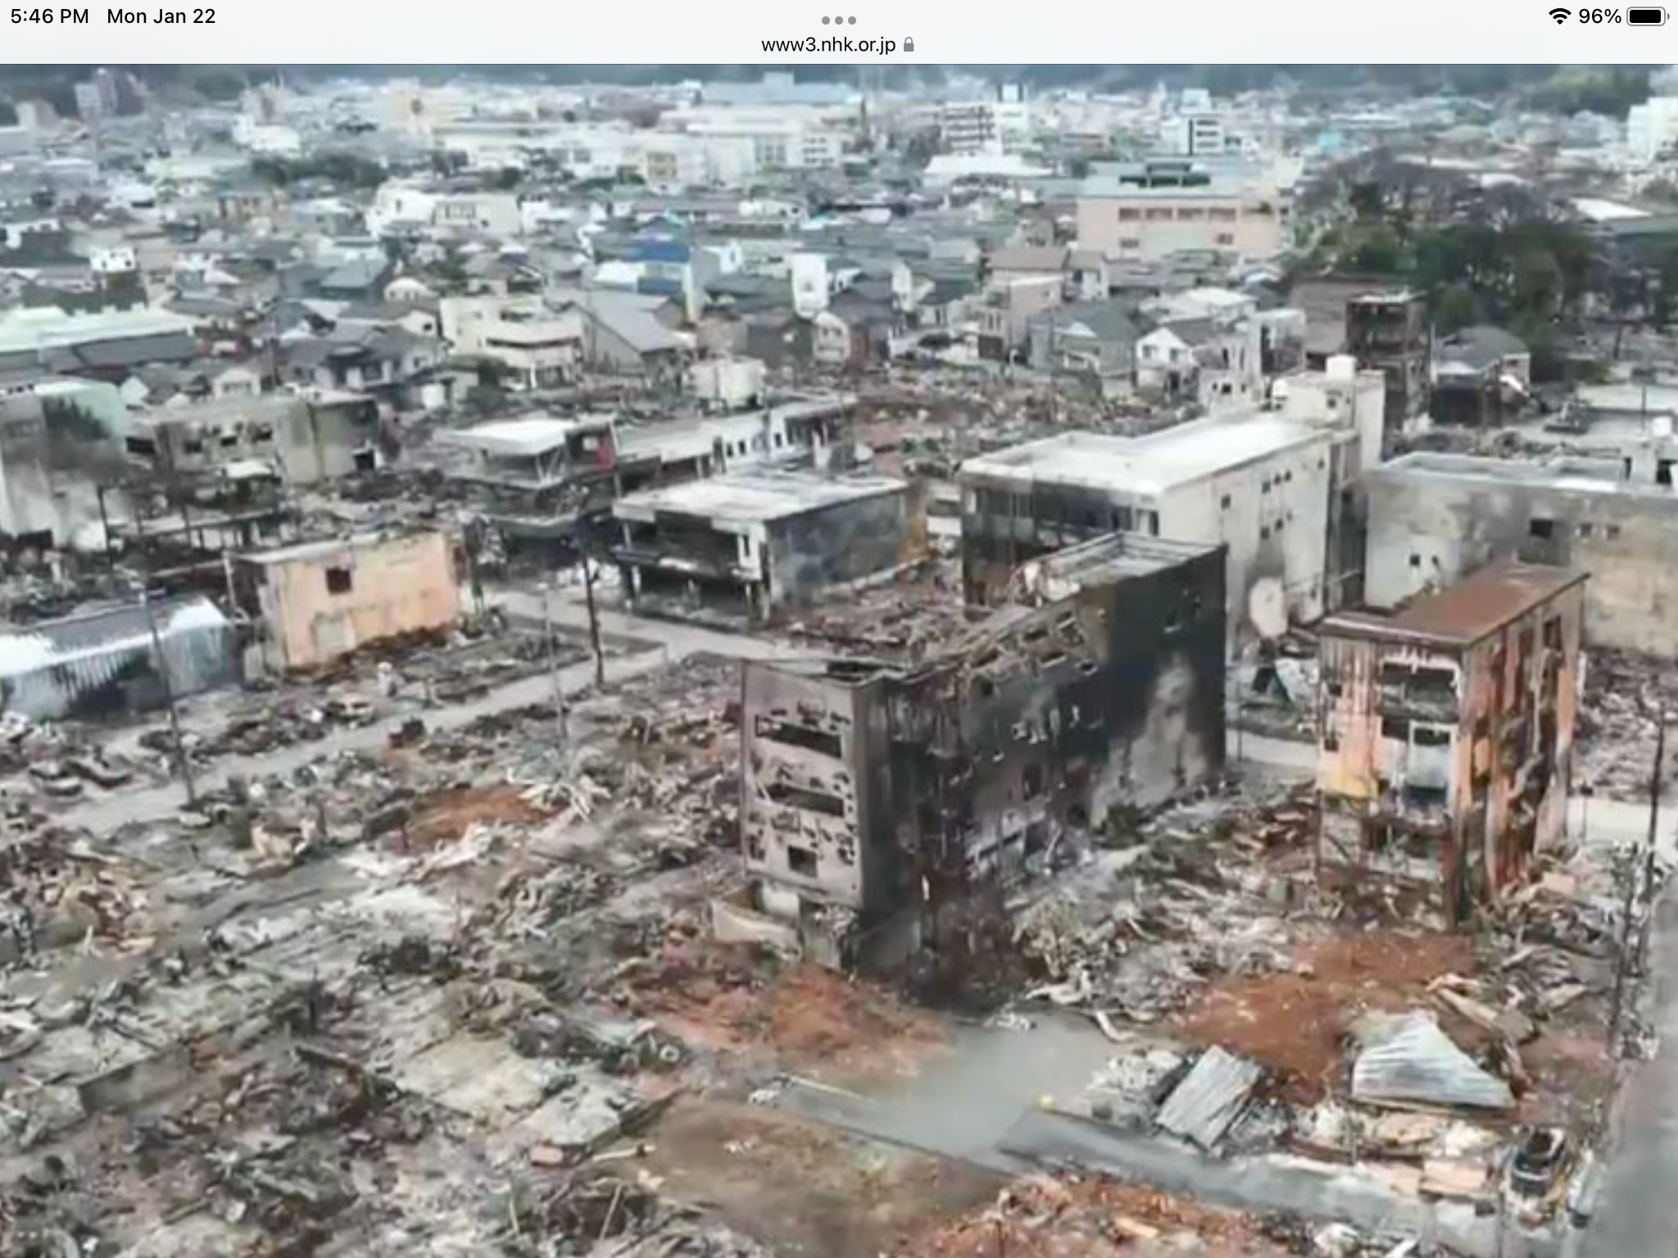

Kumamoto Band

Today is January 30th, 2024. Patrick woke up around 4:30am, got dressed, and biked to campus to meet a group of colleagues and students who, at 5:30am met and drove together to the peak of Mount Hanaoka for a 6:30am worship service. The service commemorated the 148th anniversary of the “Kumamoto Band.” This was not a band where Jimmy played guitar and Clyde played drum set while Trish did vocals. This band was a group of well-educated Christian men who became very influential during the Meiji period, when Christianity was freshly released from a 250-year ban on the faith.

Many of the Japanese men who were taught by Leroy Janes came from samurai families. When the samurai system collapsed, many of these former elite sought to regain their status in this new political system. Feudal systems were abolished in 1868, and by 1876, the students climbed the mountain and signed what is now called the Hanaoka Pledge. This pledge was a confirmation of their faith as well as a determination to maintain a moral system within Japan that was in a precarious state, since the feudal system had for centuries kept the “moral system” in check. Eventually many of these students became influential politicians and missionaries within Japan. Other bands also emerged through the work of early Protestant missionaries, including the Yokohama Band and the Sapporo Band.

Each year, on January 30th, a sunrise service is held at the top of the mountain to commemorate what must have been an extraordinary event at the time. How did these samurai overcome a centuries-old hostility towards Christianity? What points of contact were used to somehow teach men with Buddhist ethos and Confucian roots the doctrines and theology of Protestant Christianity? Reflecting on this remarkable group of individuals and their contributions to Japan during what was a particularly volatile time period is cause for reflection. I don’t imagine that while they were in the midst of their daily work that they imagined the reach of their sphere of influence that would remain for years to come.

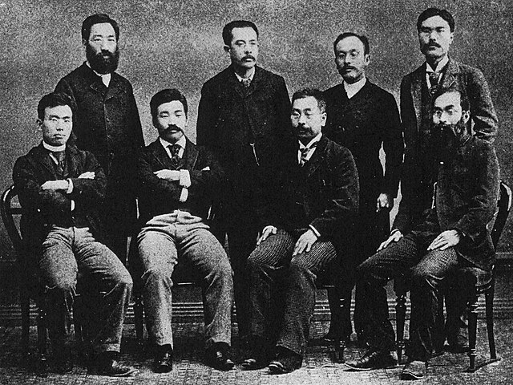

Rough start to 2024

I know that as I live out the great commission in my daily life, I often get hung up on the minutiae of the moment, rarely considering that how my interactions are slowly cultivating individuals who will be living long after I’m gone. It’s not always the big things–the top of the mountain moments– but rather the climb to get there that molds us into God’s beloved kingdom.